**EagleDream Web API – Technical Specifications**

**YOUR LOGO**

**EagleDream Web API**

**Kevin May**

**December 17, 2020**

**Version 0.0.0**

| REVISION HISTORY | | | |
| --- | --- | --- | --- |
| DATE | VERSION | DESCRIPTION | AUTHOR |
| 12/17/2020 | 0 | Initial Creation | Kevin May |
|  |  |  |  |
|  |  |  |  |
|  |  |  |  |
|  |  |  |  |
|  |  |  |  |
|  |  |  |  |

Table of Contents

INTRODUCTION 3

Project Overview 3

Objective 3

Business Case 3

Risks 3

Out of Scope 3

Technical Design Diagram 3

Technical Specifications 4

Servers 4

Software 4

Installation 4

Access Requirements 4

Databases 4

Technical Contacts 5

Assumptions 5

Concerns and Issues 5

APPENDICES 6

APPENDIX A: GLOSSARY OF TERMS 6

APPENDIX B: ANALYSIS DOCUMENTATION 6

APPENDIX C: ISSUES 6

# INTRODUCTION

## Project Overview

EagleDream professionals would like a Web API that helps them glean basic information from the data in their database. At a minimum, the API will return the following:

* An outline of user’s account balances
* The year-to-date balance of each group
* How many transactions of each transaction type have happened per month

### Objective

The scope of this project is to deliver a product to the user that can be easily scalable at any given time. The purpose of this API is that the data within the database can be accessed from different applications on different platforms.

### Business Case

The case for this project is to allow for platforms to connect to and return data based on the database.

### Risks

There are no know risks at this time.

### Out of Scope

Not applicable at this time.

## Technical Design Diagram

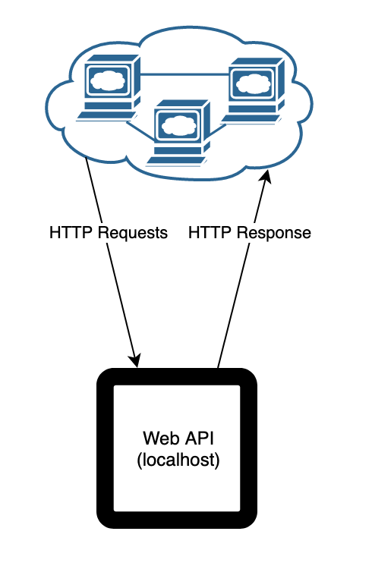

## Technical Specifications

### Servers

#### Application Servers

macOS Catalina version 10.15.7

3.2 GHz Quad-Core Intel Core i5

32 GB 1600 MHz DDR3

AMD Radeon R9 M380 2 GB

#### File Servers

Not applicable at this time.

#### Web Servers

macOS Catalina version 10.15.7

3.2 GHz Quad-Core Intel Core i5

32 GB 1600 MHz DDR3

AMD Radeon R9 M380 2 GB

#### Database Servers

macOS Catalina version 10.15.7

3.2 GHz Quad-Core Intel Core i5

32 GB 1600 MHz DDR3

AMD Radeon R9 M380 2 GB

### Software

Visual Studio 2019 for Mac

SQLite Flow

### Installation

Since this application will be executed locally only the following is required:

1. Open up the **eagleDreamWebAPI.sln** file in Visual Studio 2019 for Mac
2. Locate **appsettings.json** and update the **DefaultConnection** connection string that points to the **bank_km.db** database *(NOTE: database file has been updated, please make sure you are using the correct database)*
3. The Web API uses Swagger UI for visualization and interaction. Other software, such as Postman can also be used.

### API Calls

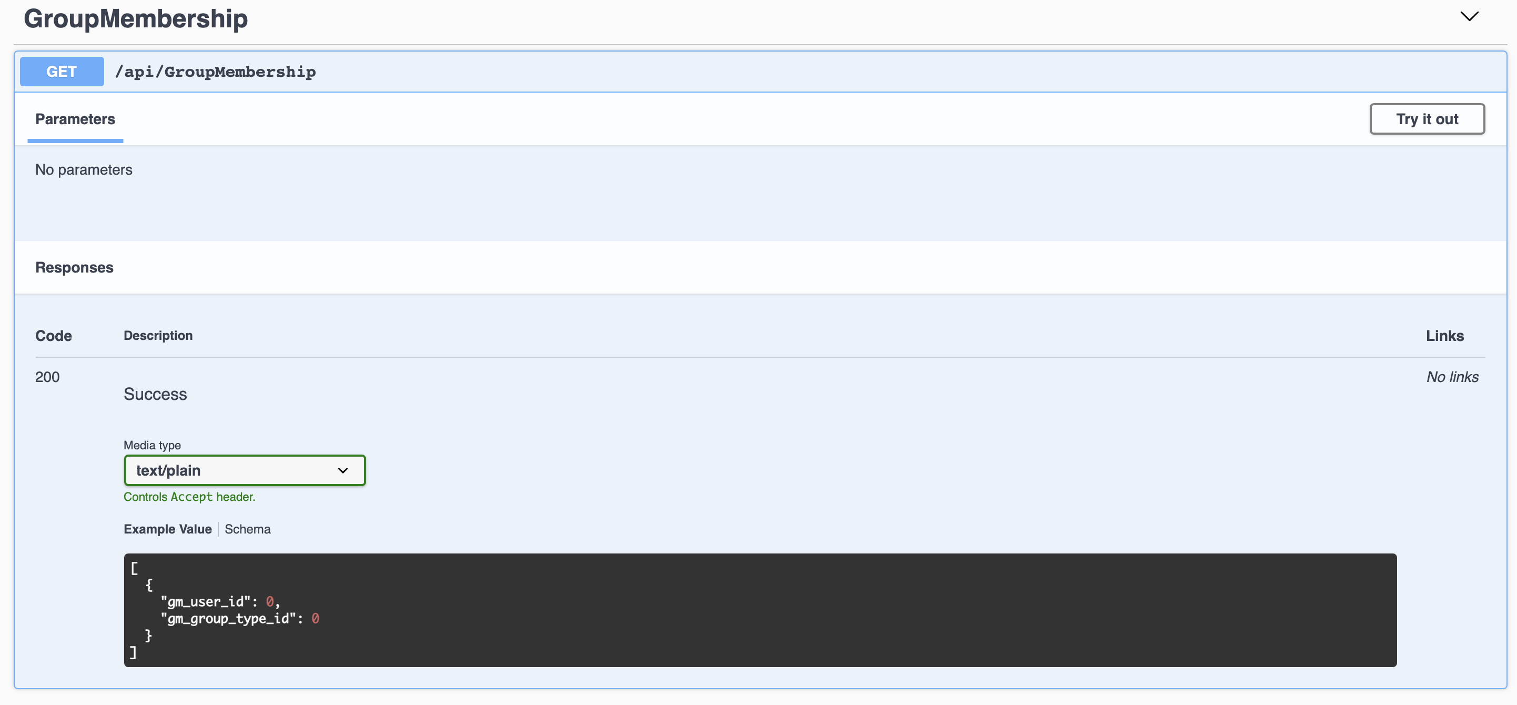

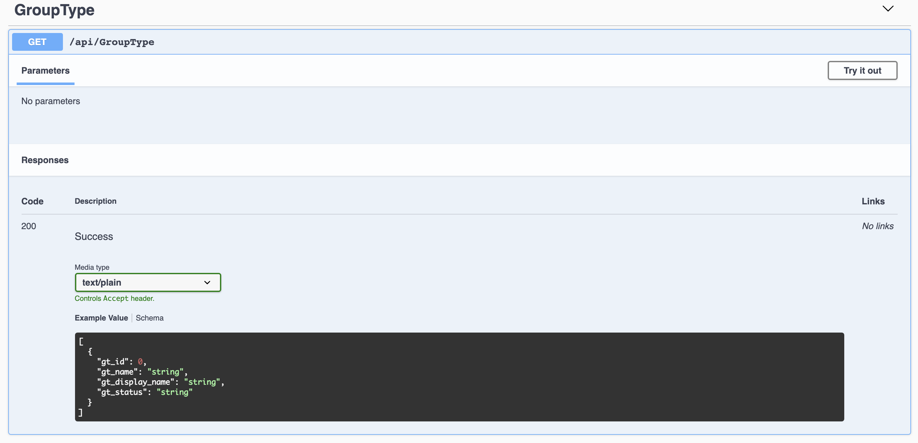

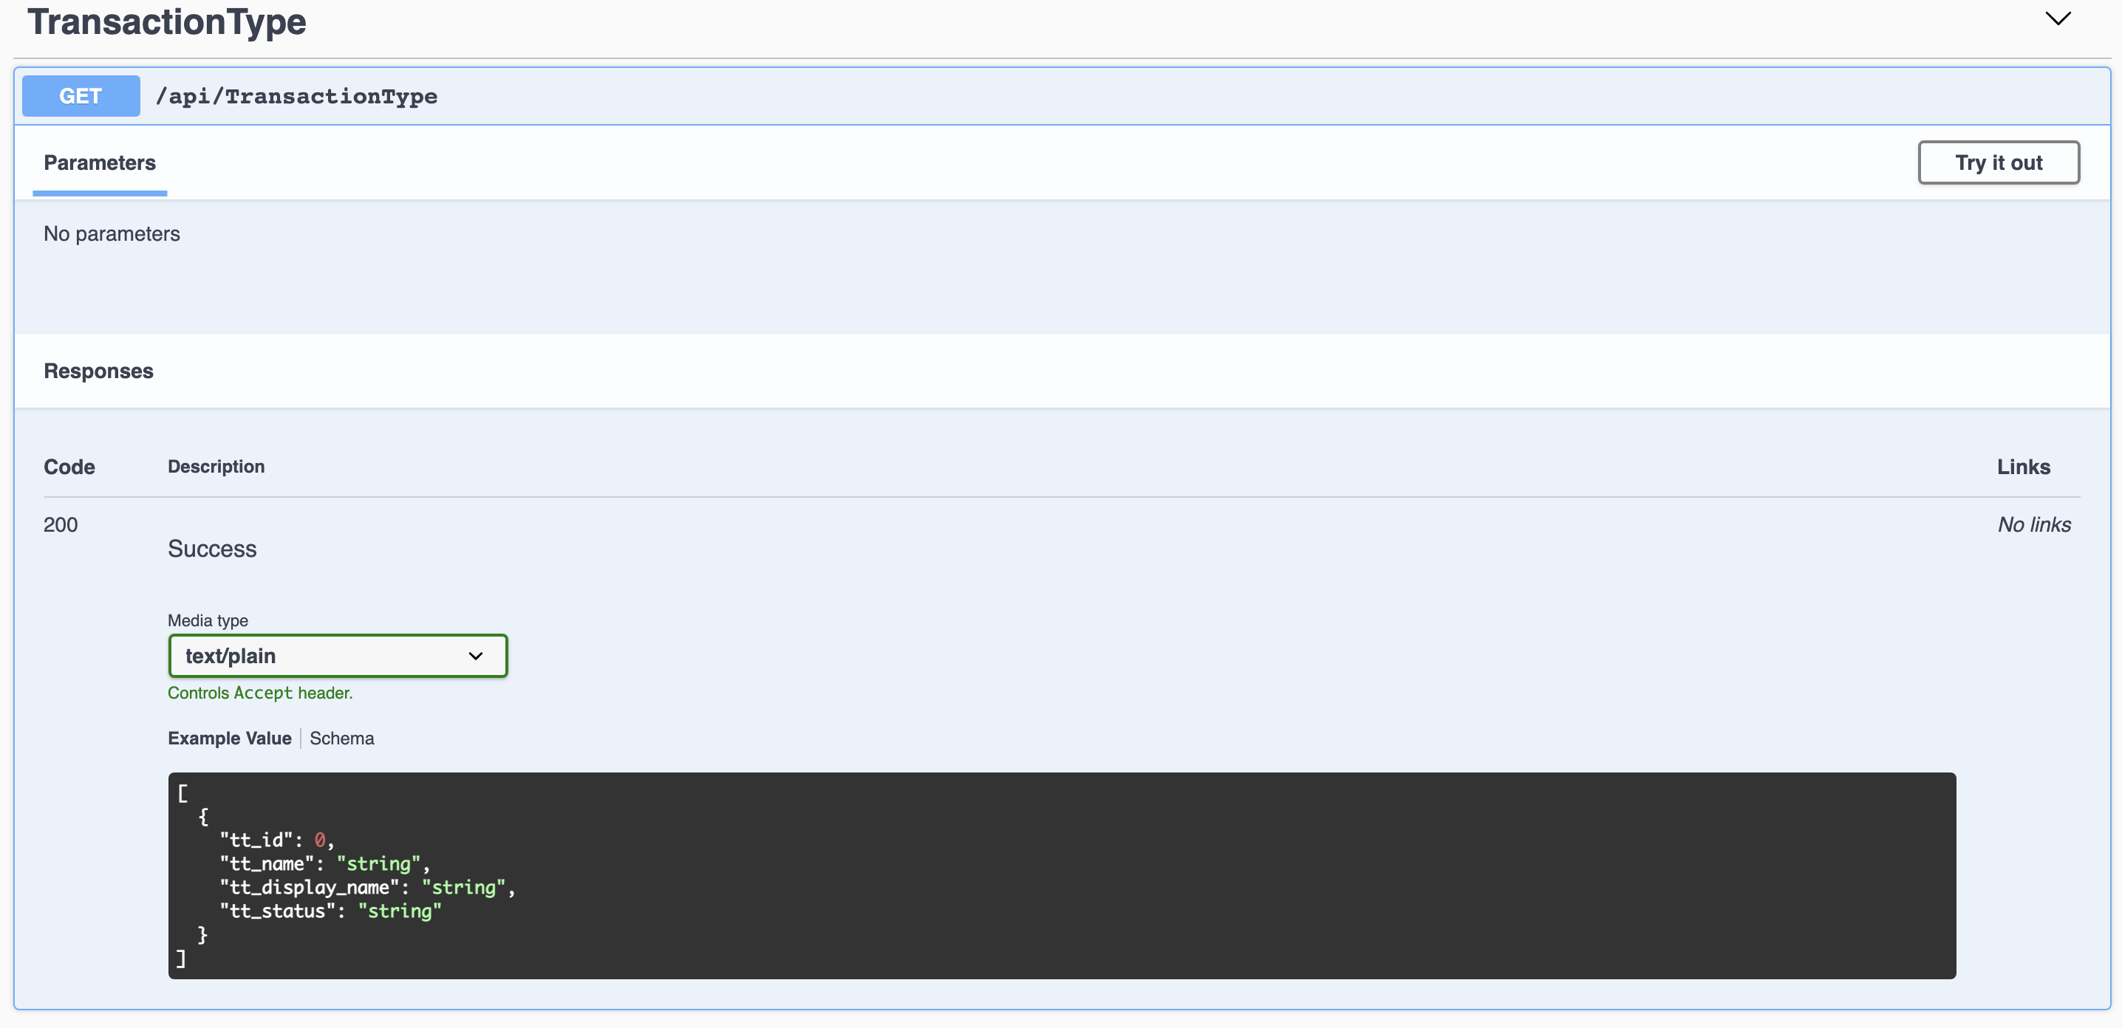

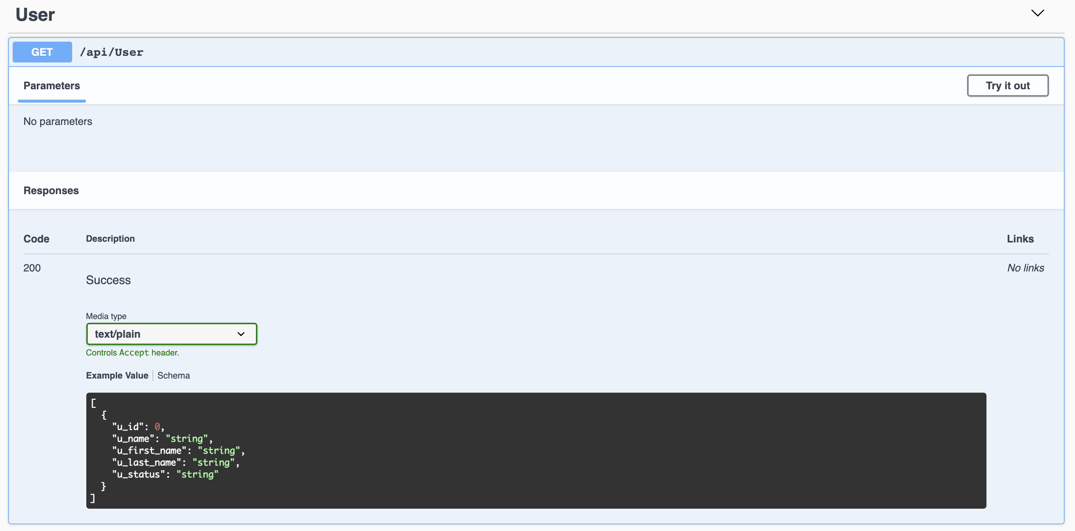

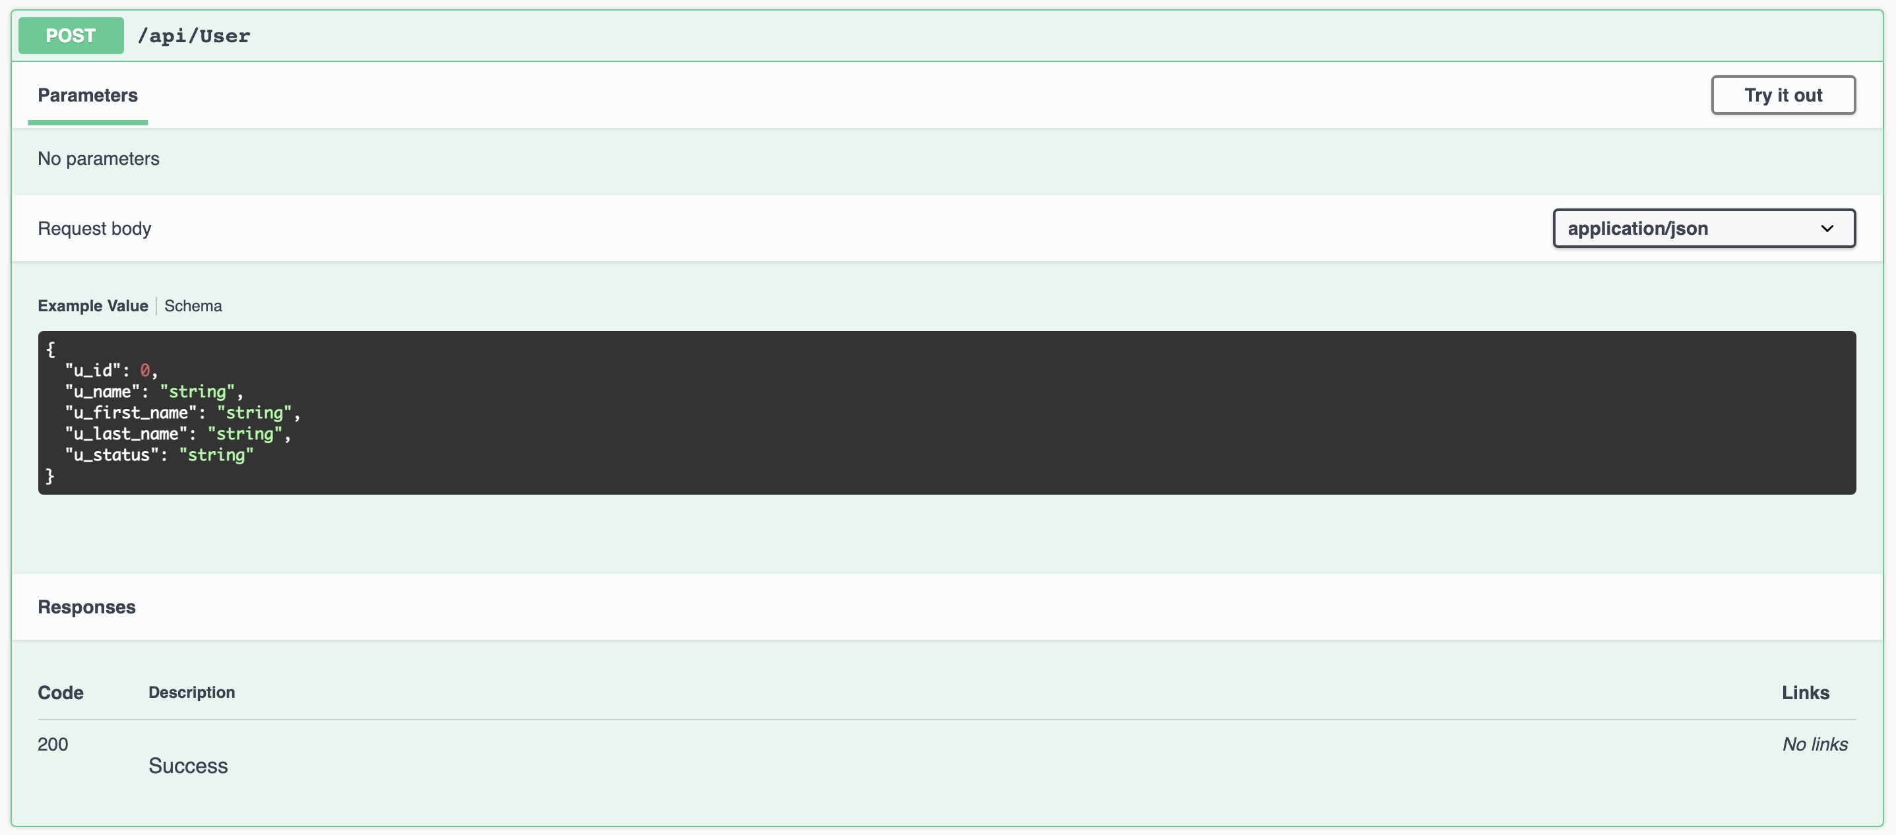

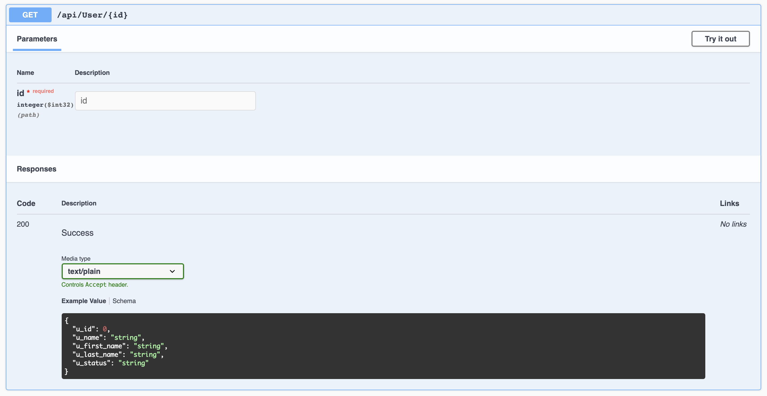

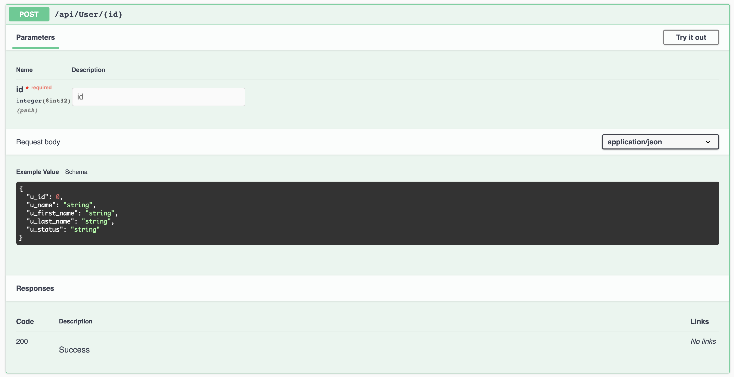

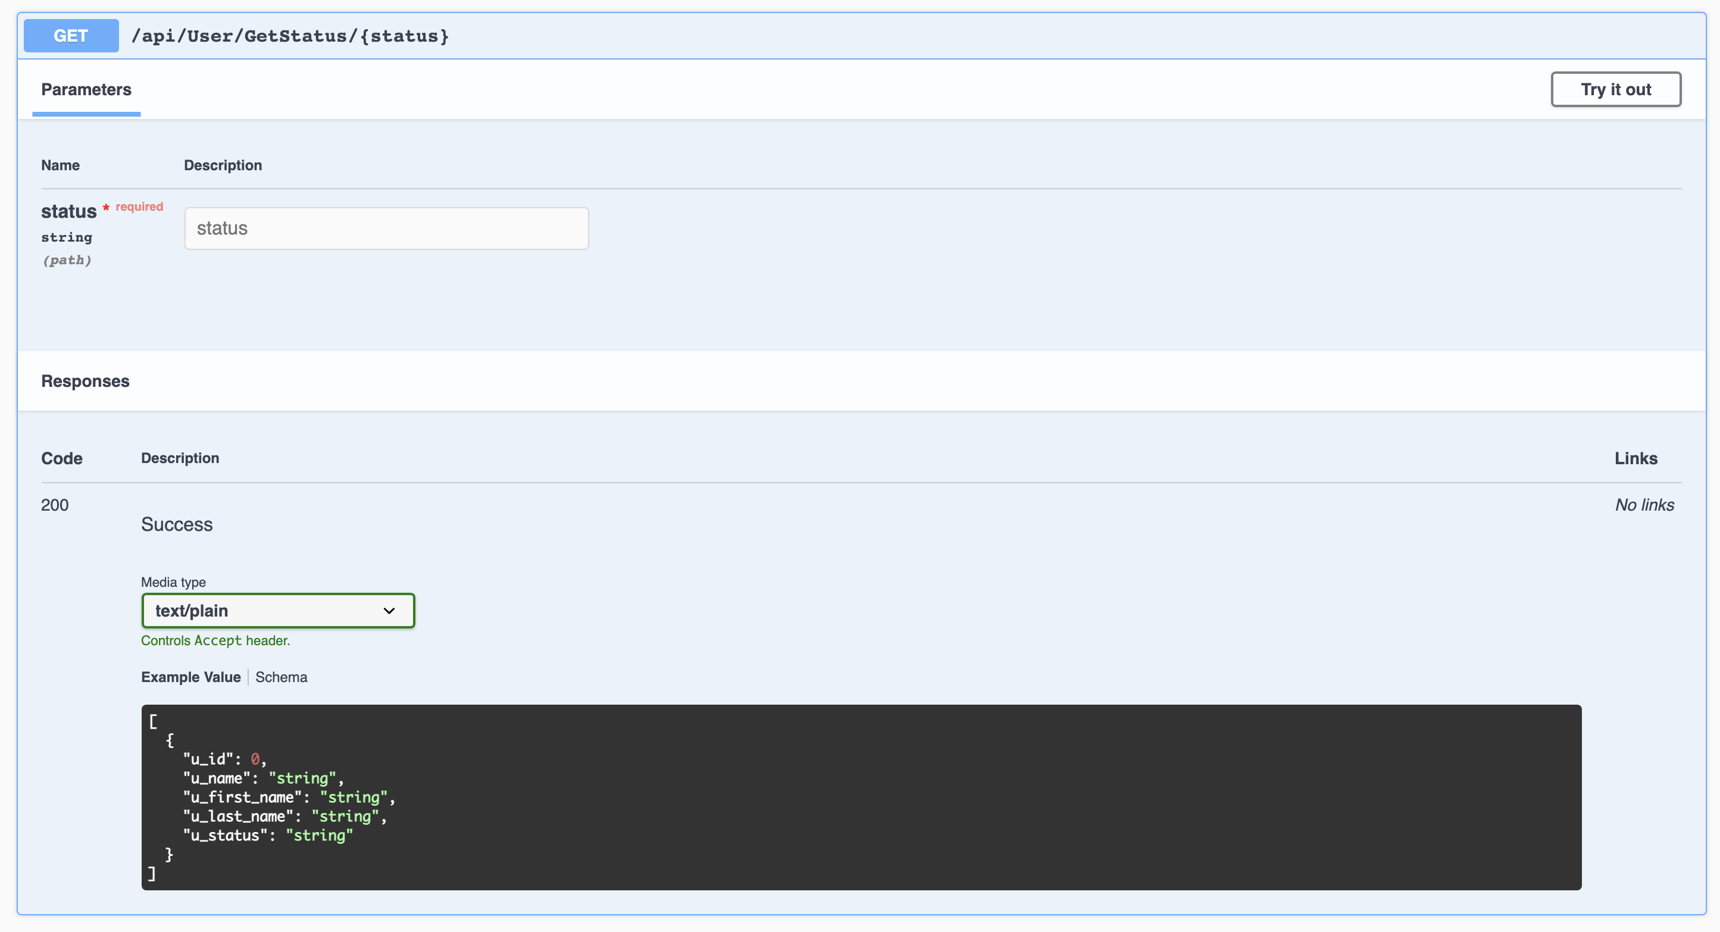

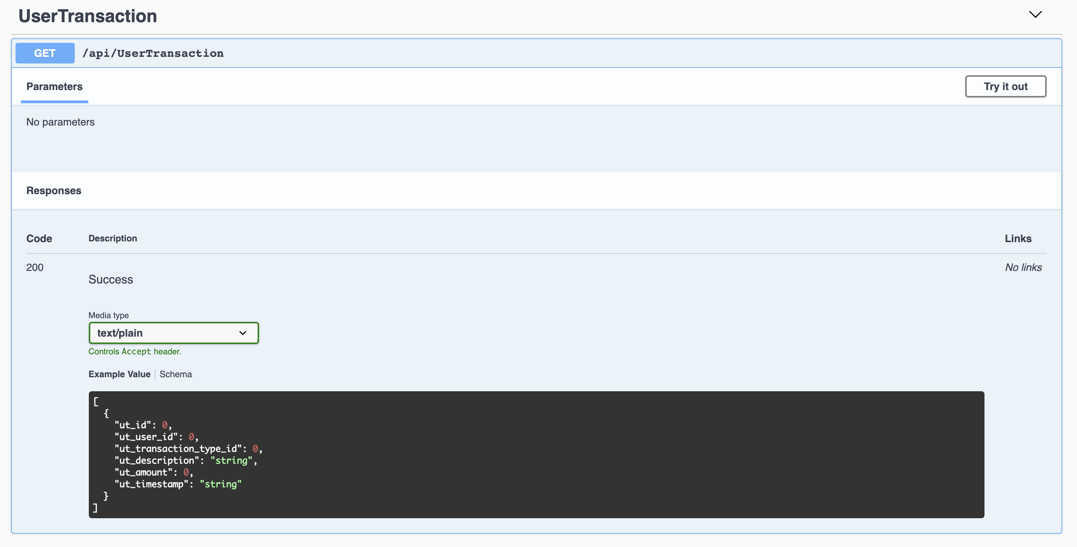

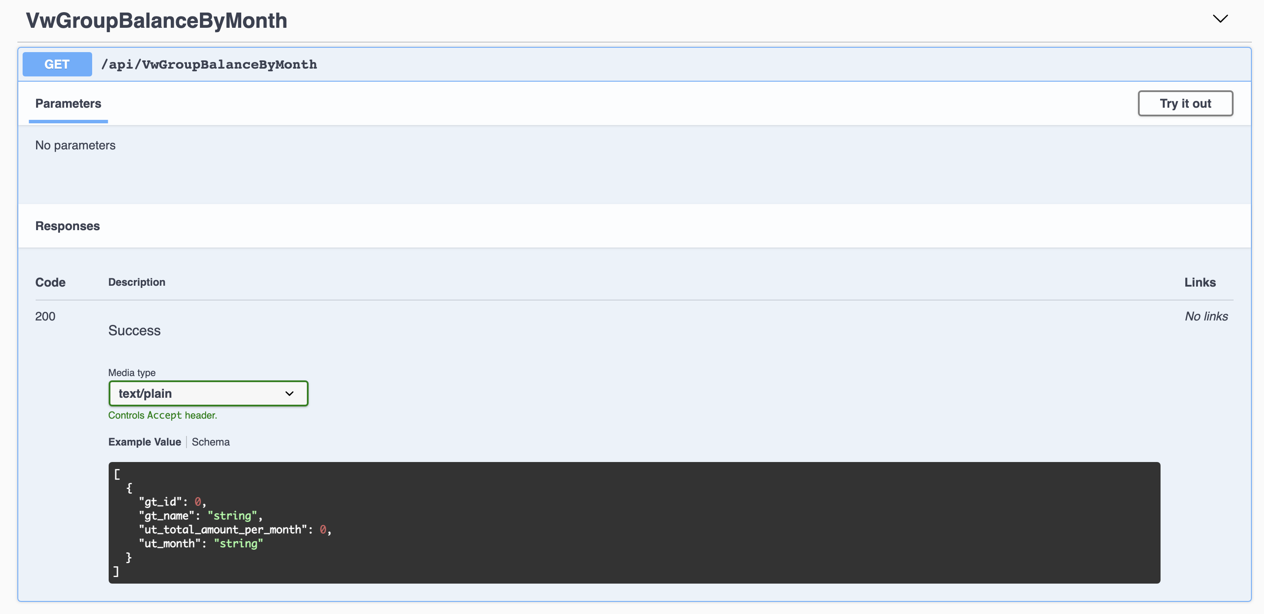

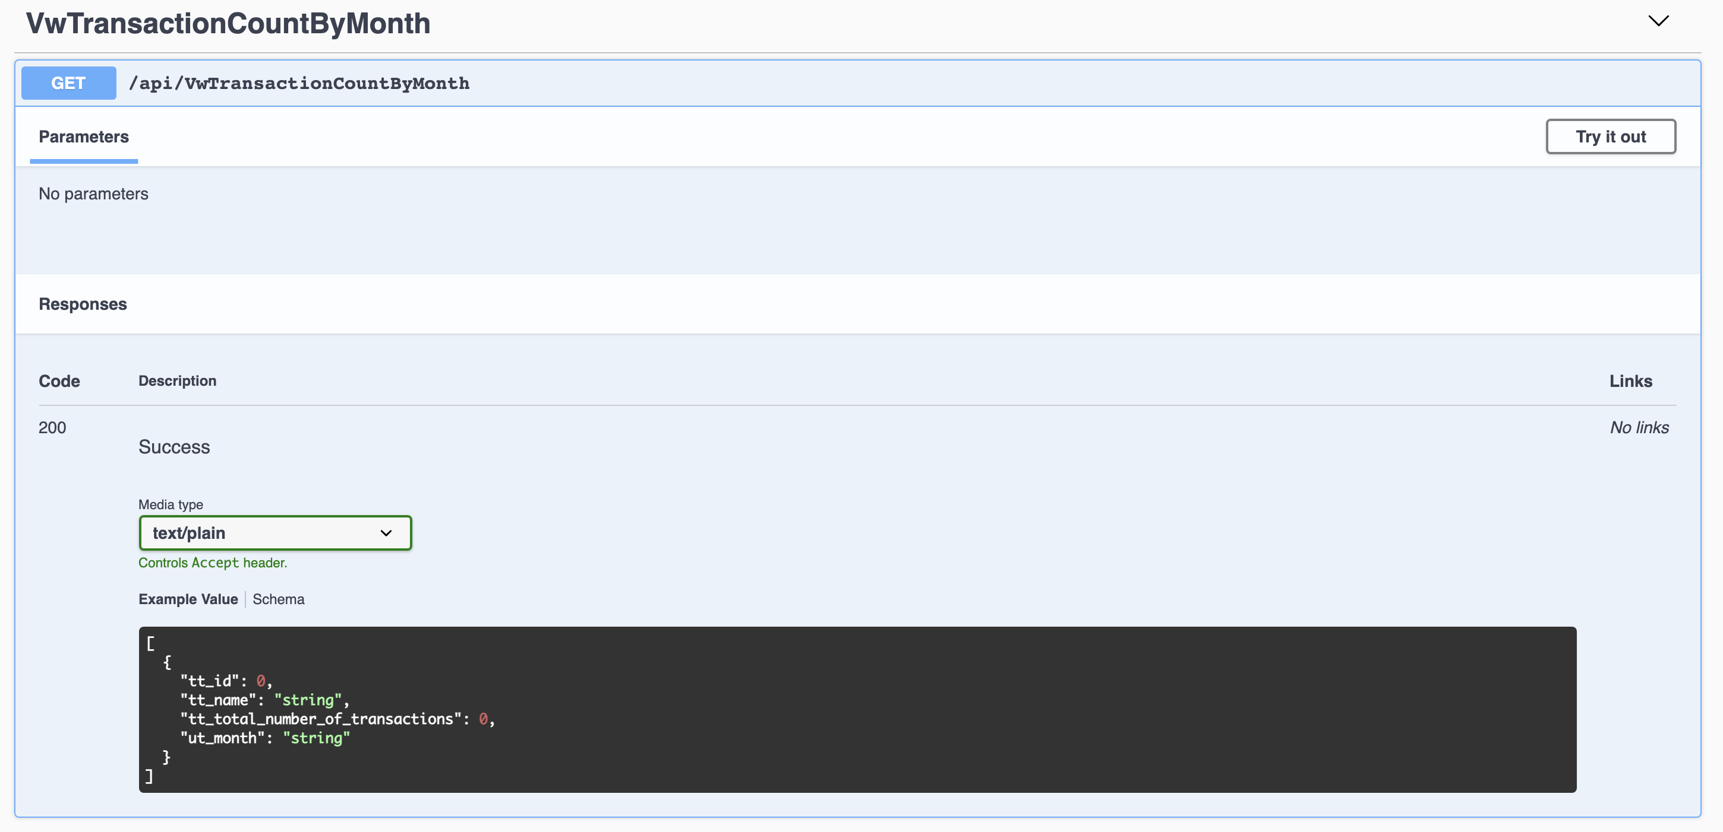

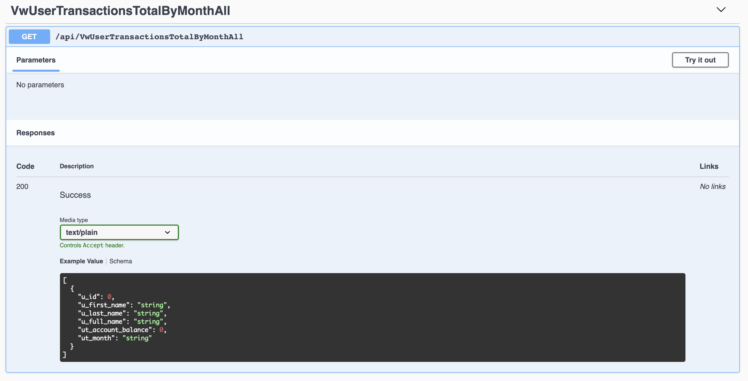

## Access Requirements

This application will be open to all users during the initial rollout. It is expected to have a total of 9 simultaneous users (12/17/2020) accessing the application.

## Databases

SQLite Database

Databases:

* group_membership
* group_type
* transaction_type
* user
* user_transaction

Views:

* vw_groupBalanceByMonth
* vw_groupTypeActive
* vw_groupTypeInactive
* vw_transactionCountByMonth
* vw_transactionTypeActive
* vw_transactionTypeInactive
* vw_userActive
* vw_userInactive
* vw_userTransactionsAll
* vw_userTransactionsTotalByMonthAll

## Technical Contacts

Kevin May – kevin.t.may@icloud.com

## Assumptions

No Assumptions at this time.

## Concerns and Issues

No concerns or issues at this time.

# APPENDICES

## APPENDIX A: GLOSSARY OF TERMS

KM: Kevin May

## APPENDIX B: ANALYSIS DOCUMENTATION

## APPENDIX C: ISSUES

List all unresolved issues, TBDs, pending decisions, findings required, conflicts, etc.

| ISSUES | | |
| --- | --- | --- |
| ID | DESCRIPTION | PARTY RESPONSIBLE |
|  |  |  |
|  |  |  |
|  |  |  |
|  |  |  |
|  |  |  |
|  |  |  |
|  |  |  |
|  |  |  |
|  |  |  |
|  |  |  |
|  |  |  |
|  |  |  |
|  |  |  |